Encoding episodic memory with hierarchical semantic associations: the use of list type to enhance recall.
Delroy Nichols
12/14/2020
Dr. Ray Johnson
CUNY Queens College

Abstract
22 Queens College students participate in an experiment that attempts to directly replicate a study from Bower et al., with few differences, to examine the effects of organization on encoding and retrieval. Given five minutes of free recall subjects are randomly placed in an organized list group or unorganized list group, utilizing a mixed design. Mean average amount of words recalled was higher with the organized list group than the unorganized and showed that repetition has an interaction with list type in mean amount of words recalled. Results are compared to Bower et al. to determine if our findings fit what has been tested in the past.

Introduction
Memory, broken into two parts, consists of semantic and episodic forms. Semantic memory refers to knowledge, our own personal dictionary of places, things, and content that we have learned throughout life (Craik, 1996). Episodic memory refers to memories of events that are personal experiences, and everyday events that occurred at particular times and places (Craik, 1996). For example, when a person learned the word dog and cow, that moment is an episodic memory. However, if we were to go to a farm and saw a dog and cow, you wouldn’t need to remember that first instance of learning to call them by their respective nouns, nor would the memory of when you learned the names ever need to come up. With this information, seeing a dog is an instance of semantic memory; remembering the first moment when you were exposed to a dog, is an instance of episodic memory.
What isn’t so simply understood is the idea that semantic memory has an underlying effect on the encoding of episodic memory. Based on the organization, this can lead to greater recall or the lack of (Craik & Lockhart, 1972). We did this study to answer the question of when words are put into an organized list, would that lead to greater recall, then if words are in a list that is presented in a more unorganized fashion.
Models of memory consist of three general stages: acquisition or registration; storing or retention; and recall or recognition (Richter, 1966). For a more simple account, we will refer to the referred three stages as; encoding, storage and retrieval (Craik, 1996). There is a short term memory store which takes in auditory and visual information from the sensory experience; with the use of attention, information then enters the short term memory. Long –term memory is created with the rehearsal of items in the long term memory store, which then inputs information into the long term memory (Craik, 1996). Short term memory deals with recall when exposed to visual or auditory information for less than 5 seconds. Long-term memory deals with retrieval of information that was presented over a longer period of time (>15 seconds) and can include more content (Craik, 1996). We don’t want to fall into the trap of an absolute temporal designation for long-term memory, therefore anywhere from 5-15 seconds should be a safe target for the utilization of long-term memory.
Organization in Memory
The presentation order of the categorized word list has been identified as a key variable in the recruitment of semantic word associations. There are two lists used as independent variables in this study. One list consists of 4 words, these 4 words will belong to the same taxonomic category displayed directly above the group of words, and this list will make up our organized list group.
The unorganized list group will consist of the same 4 word pattern but will contain words that have no association to the taxonomic category displayed above the group of words. We theorize that the organized list will promote better recall than lists that don’t share direct taxonomic similarities.
Organization in this experiment is therefore defined as a group of 4 nouns that are all directly related to the taxonomic category placed above the word group.
Usually, organization effects are removed from a study because they operate on the independent variable, but this is exactly the effective manipulation needed to validate any findings of greater recall of words.
Repetition Effects
Bower had 4 trials in his experiment. We can then ask the question if this amount of time to encode information and recall gave him an unnecessary advantage. To answer this we would need to know if repeating the study does give an advantage; which is one of the experimental questions we hope to elucidate with our experiment. Given the idea that the more time exposed to content should help with retention efforts, we expect to see a greater percentage of words recalled in the second trial for both groups, whether in the unorganized group or the organized group (Craik & Lockhart, 1972). We feel this way because part of being able to retain stimuli depends on study time, amount of material presented, and exactly what the subjects are told they are being tested on (Craik & Lockhart, 1972).
Level of Processing
We propose that items that are placed in an organized list under taxonomic categories will administer greater recall than those that are placed in categories with random or unrelated words filling in. Craik and Lockhart, make the case that retention not only depends on study time, amount of material presented and mode of test; but also depends on the extent to which the subject has developed systems to analyze and enrich particular types of stimuli (Craik & Lockhart, 1972). We can separate these levels of processing stimuli into a preliminary stage and a later stage. The preliminary stage will store information about the physical and sensory features of information such as: lines, shapes and angles. The later stage of encoding will match information with stored abstractions to find patterns and extract meaning (Craik & Lockhart, 1972). This hierarchy of encoding lies on a continuum, therefore, further “depth” refers to a stronger semantic and cognitive analysis (Craik & Lockhart, 1972).
We expect deeper levels of processing to aid in recall, due to the semantic encoding we generate with the use of our taxonomic categories in the organized list group. The list group that generates more semantic associations should generate stronger recall. The unorganized list group, because of its random nature, should not generate the same semantic associations or allow participants to use cues to help with encoding. What we want to see from these experiments is semantic encoding promoting episodic retrieval.
Present Study
In this study we will test our hypothesis that a structured (organized) list will induce greater recall because it gives participants a plan in how to encode the information to set themselves up for better retrieval down the line.
Our experiment has striking similarities to Bower et al.’s and very minor differences. The similarities begin with; word lists being used, our subjects were exposed to a very similar word list, the structural component, a continuum of associated nouns that were separated by four levels, how long subjects were given to encode and recall word stimuli, one minute to encode each of the four lists, and five minutes to recall all of the words shown in one trial. Bower used slightly more words than we did and he also conducted four trials instead of two. In those four trials, Bower et al. exposed their subject group to category levels 1 and 2 in Trial 1, 1,2, and 3, in Trial 2 and 1, 2 ,3, and 4 in Trials 3 and 4 (Bower et al., 1969). Given our hypothesis that greater semantic association will generate a stronger ability to recall, we expect that Bower et al.’s percentage of words recalled will be greater between Trials 3 and 4 than we will see in our Trials 1 and 2. We have that expectation because Bower et al.’s subjects will have had more time to encode the words into memory; they will be exposed to fewer words in the same one minute time frame, and granted more time to formulate a plan for word retrieval (Bower et al., 1969).
The major difference between our study and Bower et al.’, is that they had six experimental conditions, creating different patterns of exposure that allowed him to test the hypothesis in finer detail (Bower et al., 1969). We used 104 total words in our study to be recalled, and Bower et al. used 112 (Bower et al., 1969. Our use of two trials came from the idea that being exposed to the categorical words for such a long period of time almost made those words a guarantee to be remembered and therefore worked against the relative validity we hoped to maintain. Any mental cues from this organization effect would have been welcome, but the idea of a phonemic benefit was without justification. Other studies have used two trials and found significant results without a significant difference in standard deviation.
The word lists weren’t exactly similar in layout; an example will be given in the Methods section, under Stimuli. Since Bauer did not measure intrusions we decided to look at intrusions.
We want to understand if organization promotes better recall and will repetition administer an advantage in subjects’ ability to recall. Bower surmised that organized material is easier to learn and organization aids recall by providing cues to possible items (Bower et al., 1969). We initially agree with his findings and hypothesize that the organized list creates a retrieval plan for free recall. The characteristics of this retrieval plan are that it tells participants where to begin their recall, how to proceed from one unit to the next systematically, and what words are to be expected in each categorical unit (Craik & Lockhart, 1972). This theorized retrieval plan is created by being exposed to the categories in hierarchical fashion. Therefore, we should observe an interaction in our results where the difference in amount of words recalled should be higher from Test 1 to Test 2 in the organized list group than when compared to Test 1 and Test 2 of the unorganized list group. Our experiment plans to test this hypothesis by demanding recall of organized information and unorganized information. Subjects who show better recall with organized lists will substantiate the idea encoding efforts improve when attempted in an organized fashion (Howe, 1966).

Methods
Participants
There were 22 participants included in the study, ages ranging from 18-50 years old. All participants were Queens College undergraduate students enrolled in a Psych 313 course. Subjects were not compensated for their time as the experiment was required for the class. Sexes were represented in the study, nine females in group 1, and seven females in group 2. All participants had normal or corrected to normal vision and a majority were right-hand dominant. Subjects gave informed verbal consent in order to participate in the experiment. There was a higher range of ages in group 1, [19-35] than there were present in group 2 [19-24]. Mean age, mean years of education, English as a first language, handedness, and sex were all similar between groups.

Groups | Mean Age | St. Dev. Of Age | Mean yrs. of Education | Non Native Speaker | Handedness (Right) | Female
Group 1(n=11) | 22.3 | 4.16 | 15.3 | 3 | 9 | 9
Group 2 (n=11) | 20.9 | 1.23 | 15.6 | 3 | 9 | 7

Design
There were 2 groups of subjects, both with 11 participants. Participants used personal laptops with the software PsychMate that allowed participants to take part in the same examination as other participants who were part of the group. The two independent variables were list structure: Organized, and Unorganized; and trials: Block 1 and Block 2, which was a repeated test of the same list structure. The list structure variables were factored with a between subjects design and the repeated tests followed a within subjects design. There are two independent variables in this study, list type and test; the dependent variables are number of words recalled and number of intrusions. The control in the experiment came from both groups getting the same words to recall.

Stimuli
The stimulus used in the organized group is provided in an example below. Hierarchical taxonomic categories are presented in an adjacent order at level 1-3 of the word list. When we refer to levels here, refer to figure 4 that show what level denotes each hierarchy of the word list.
Showed in figure 4 is how the words appeared on the screen in hierarchical fashion, with there being 1 word in level 1, 2 words in level 2, which could branch into two or three categories in level 3, and 3 or 4 words in level 4. All adjacent words were taxonomically associated.
In the organized list group this association follows a continuum similar to taxonomic order (i.e. Phyla, Kingdom, Class, and Species) of associated words that get more specific as the levels increase. In the unorganized list group level 1, 2,and 3 don’t have to contain broad nouns at all, as shown in figure 5, the list of words show very few, if any, external associations in the 4 word lists presented.

Figure 3: Example of an organized list presented to group 1
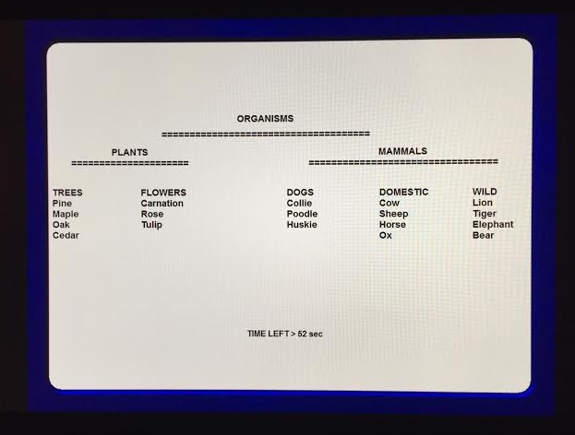
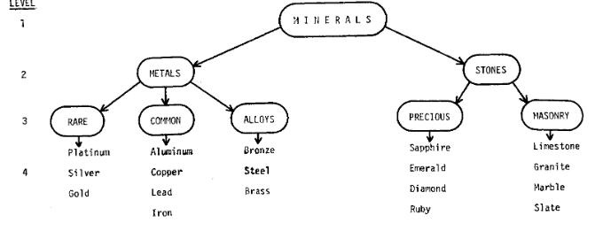
Figure 4: Words separated into hierarchical levels, with a similar formation found in both list types.
Figure 5: Example of an unorganized list utilized in the experiment.
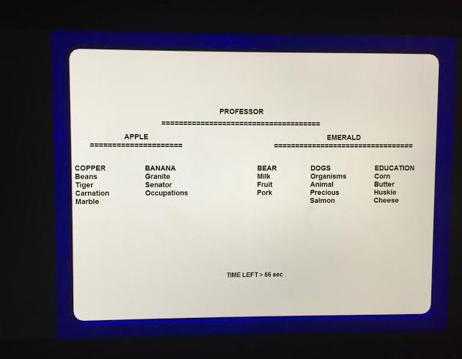
Procedure
Subjects were informed before the presentation of any word lists that they will be presented with lists of 26 words each. They were not told how many lists there would be. They were told that each list would be presented for one minute. During their 1 minute, participants should be attempting to study the words on their list and trying to remember as many words as they can. There was no time given in between lists. Subjects were then informed that after all of the lists are presented, they will have 5 minutes to recall as many of the words as they can in any order. Then after the recall phase, the whole procedure will be repeated. Subjects were required to have two sheets of paper, and a writing utensil to write down the words that they recall. The above information was a summarized version of what was told to the participants before the word lists were presented.
Subjects were displayed with their first word list after pressing spacebar to continue. They had 1 minute to memorize this word lists without writing any information down. The word lists, examples shown in figure 3 and figure 5, lasted 1 minute and then immediately moved on to the next word list. When all 4 were completed a timer started for 5 minutes and subjects were asked to write down all words they could remember in the same order and configuration that they remember them on the screen. After the 5 minute recall session, there was an alerting noise emitted from the software and participants were shown a list of all 104 words and asked to verify which words were correct and if any of the words they recalled were false positives. Subjects entered the numbers they recalled correctly and were told to put their focus back on the screen then continue when ready by pressing the spacebar. Once participants pressed the spacebar, the whole procedure was repeated from the time of exposure to the exact same word lists.

Results
Organization Effects
A significant interaction of list type and test was detected, F(1,20) = 10.7, p=0.001. For those in the organized group there was a larger change between Block 1 and Block 2 than was found with the unorganized group.
As depicted in figure 1, the analysis showed a significant effect of list type on mean number of words recalled made by the participants in the study F(1,20)=49.5, p< .05. Mean number of words recalled was significantly higher for those placed in the Organized List group (M=69.7) than those placed in the Unorganized List group (M=30.6).
The results of the analysis yielded significant differences in mean number of words recalled and tests [F(1,20)=43.7, p<.05].
There was a significant interaction between list type and trial number that was examined through five contrasts. A significant interaction between block 1 and list type was detected F(1,20) = 26.8, p<0.05, block 2 and list type F(1,20) = 49.3, p<0.05, organized list and test F(1,20) = 10.2, p<0.05, unorganized list and test F(1,20) = 71.7, p<0.05, organized list in test 1 against unorganized list in test 2 F(1,20) = 35.3, p<0.05.
Intrusions
We failed to find a significant main effect of test on intrusion, list type on intrusion and no significant effect of test and list type on number of intrusions.

Discussion
Effects of Organization
The list type organization showed that organization in memory promotes better recall in our experiment. In contrast to earlier studies done on the subject, we were able to find a significant main effect organization on mean amount of words recalled. We believe that this is due to a stronger manipulation of the variable that was found in earlier studies, but more closely resembled the experiments that Bower et al. formulated.
Our results found significant main effects in very similar conditions that were analyzed in Bower et al.’ experiments but there were some minor differences that raised some questions. Bower et al. found that their subjects were able to recall all the words without trouble in the third and fourth trial that included presenting all of the words. Even in trials where level 3 and 4 words were progressively blocked found results where participants were able to remember all of the words clearly. Bower et al. didn’t measure intrusions but according to his study, participants had to say the word verbally aloud, so any false positives would have been noted by the practitioners present in the experiment. The proficiency of memory shown by Bower et al.’ participants could be due to the smaller amount of subjects in his study, as well as a difference in education levels of the group. Bower et al. recruited Stanford graduates for his study, which features an acceptance rate in the bottom 10th percentile of all schools, while Queens College didn’t feature the same stringent acceptance process, just the top 60th percentile (College Board, 2020).

Effects of Repetition
We found that results for Block 2 for the unorganized list group yielded the highest amount of words recalled throughout all the conditions recorded in this experiment. The results are in line with what we expected before we ran the experiment due to subjects being already exposed to the words, the increased study time, and exposure to the structural organization of the words that lead to more efficient cueing efforts. These explanations all exist in the paradigm of converting words in the long term memory store to long-term memory through rehearsal efforts. What’s important to note in these results is that we found the difference in words recalled higher for the organized list when compared to the effect of repetition on the unorganized list. Recall for Block 2 in the unorganized list grouping featured an average of 13 words increase through 11 participants that featured a 15.6 standard deviation.

Intrusions
We failed to find a significant main effect of test on intrusion, list type on intrusion and no significant effect of test and list type on number of intrusions.
Conclusion
It is apparent to me after analyzing this experiment that when I am trying to learn new information it would benefit me to talk it over in a conversation with friends, try to teach it to a group of people, or even try to find similar information to relate the new information with. Deeper semantic encoding of episodic memory can be achieved by extracting meaning and recognizing patterns in everyday material and items that benefit me to memorize (Craik and Lockhart, 1972).
Through learning this study I believe it will affect the way I study information in the future. Organized lists induce my semantic memory and will further induce memorization with continued repetition.

Limitations
The subjects are limited to people in their early 20’s and may not work for older aged individuals due to differences in hippocampal activity and blood flow.

References
College Board - SAT, AP, and College Planning Tools. (2020, December 08). Retrieved December 16, 2020, from https://www.collegeboard.org/
Craik, F. I., & Lockhart, R. S. (1972). Levels of processing: A framework for memory research. Journal of Verbal Learning and Verbal Behavior, 11(6), 671-684. doi:10.1016/s0022-5371(72)80001-x
Bower, G. H., Clark, M. C., Lesgold, A. M., & Winzenz, D. (1969). Hierarchical retrieval schemes in recall of categorized word lists. Journal of Verbal Learning and Verbal Behavior, 8(3), 323-343. doi:10.1016/s0022-5371(69)80124-6
Craik, F. I., & Lockhart, R. S. (1996). Models of Memory. Introducing Psychological Research, 310-316. doi:10.1007/978-1-349-24483-6_47
Howe, M. J. (1966). A Note On Order Of Recall In Short-Term Memory. British Journal of Psychology, 57(3-4), 435-436. doi:10.1111/j.2044-8295.1966.tb01048.x
Hodges, J. R., & Graham, K. S. (2002). Episodic memory: Insights from semantic dementia. Episodic Memory: New Directions in Research, 132-152. doi:10.1093/acprof:oso/9780198508809.003.0008
Richter, D. (1966). Biochemical Aspects of Memory. Aspects of Learning and Memory, 11-14. doi:10.1016/b978-1-4831-6777-0.50010-6

Tables
 | Unorganized | Organized
Block 1 | 24(9.6) | 50.3(8.7)
Block 2 | 37.2(15.6) | 89(14.8)

Groups | Mean Age | St. Dev. Of Age | Mean yrs. of Education | Non Native Speaker | Handedness (Right) | Female
Group 1 | 22.3 | 4.16 | 15.3 | 3 | 9 | 9
Group 2 | 20.9 | 1.23 | 15.6 | 3 | 9 | 7

Figures
Figure 1: Mean amount of words recalled in both word list groupings in the mixed design.

Figure 2: Mean amount of intrusions recorded in both list types and both trial conditions.

Figure 3: Example of an organized list presented to 11 participants in Group 1.

Figure 4: Words separated into hierarchical levels, with a similar formation found in both list types.
Figure 5: Example of an unorganized list utilized in the experiment.

